What is an Xpath?

XPath is defined as XML path. It is a syntax or language for finding any element on the web page using XML path expression. XPath is used to find the location of any element on a webpage using HTML DOM structure.

In Selenium automation, if the elements are not found by the general locators like id, class, name, etc. then XPath is used to find an element on the web page .

Types of xpath

1.Complete or absolute xpath

2.Partial Xpath

3.Custom Partial Xpath

4.CSS Selectors

Now we will discuss each and every term listed above and we will under each term in detail and how to make use of it.

**Complete or absolute xpath:-**

If location path starts with root node or with '/' then it is an absolute path. Following are few of the example locating the elements using absolute path.

Example:-

**html/body/div[1]/div/header/div[1]/div[1]/div/ul/li[1]/a**

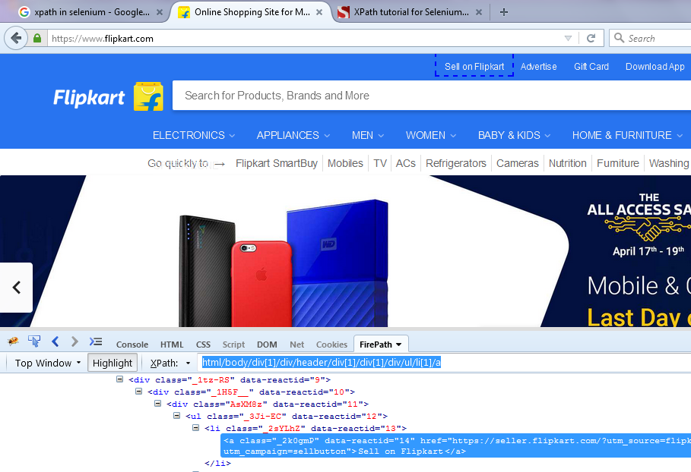

Now lets understand how this absolute xpath is written

1. Open your application
2. Press Ctrl+F12
3. Click on the firepath
4. Click on the firepath dropdown icon and select the “Generate Absolute path”

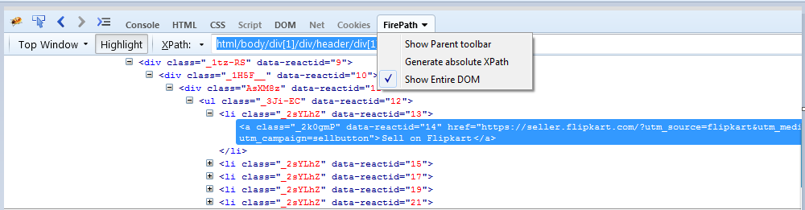

In Some cases say like interview point of view the panel will ask you to write without using firebug.Now how can we handle this. No panic just follow the below steps.

1.Oen your developer tools by pressing **ctrl+F12** it will navigates you to the developer tools option

2.Click on the mouse pointer option



3.Now Select your Test Object

4.It will show the structure of the object in the DOM.

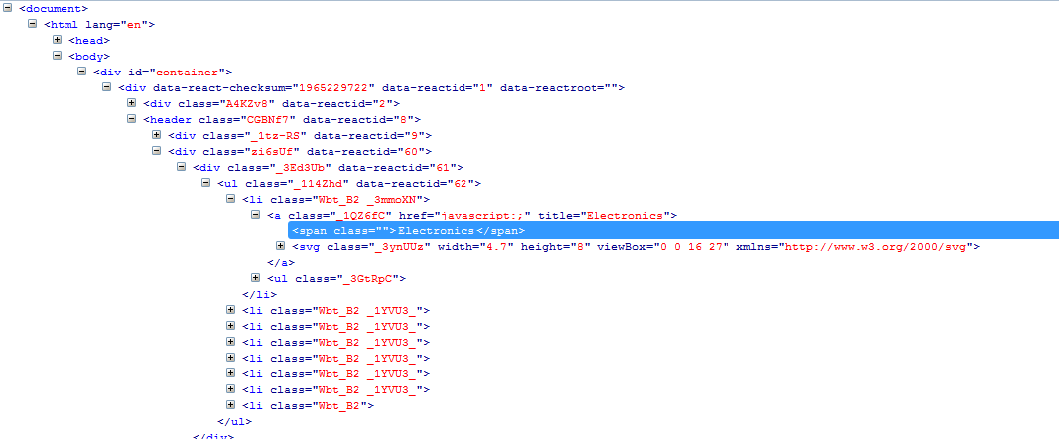

5.Now start from the Html tag and see the how the hierarchy follows.

Lets take an example

On the flipkart website I want to write the absolute xpath without using the firepath, your xpath will look like this

**html/body/div[1]/div/header/div[2]/div/ul/li[1]/a/span**

The ***disadvantage*** of the absolute XPath is that if there are any changes made in the path of the element then that XPath gets failed. The key characteristic of XPath is that it begins with the single forward slash(/) ,which means you can select the element from the root node.

**How to Write your partial or relative xpath?**

For Relative Xpath the path starts from the middle of the HTML DOM structure. It starts with the double forward slash (//), which means it can search the element anywhere at the webpage.

You can starts from the middle of the HTML DOM structure and no need to write long xpath.

Below is the example of a relative XPath expression of the same element shown in the below screen. This is the common format used to find element through a relative XPath.

**Syntax:-//Htmltag[@ attributename=’value’]**



**Relative xpath:-**

.//div[@id='container']/div/header/div[2]/div/ul/li[1]/a/span

Below are the HTM tags and the mandatory attribute values

|  |  |  |  |
| --- | --- | --- | --- |
| **HTML Object** | **Tagname** | **Mandatory Attributes** | **Optional Attributes** |
| Input Field | input | type="input"or"email" | id,name,class |
| Button | input | type="submit" | id,name,class |
| Radio buttons | input | type="radio" | id,name,class |
| Checkbox | input | type="checkbox" | id,name,class |
| Link | a | href | id,name,class |
| Images | img | src | id,name,class |
| Dropdown | select |  | id,name,class |
| Text | div,span,p,h1,h2…. |  | id,name,class |